* We will get a blank page when the URL of the created Webapp without code is clicked. It will say the app service which was configured by you is running. <https://github.com/Azure-Samples/app-service-web-dotnet-get-started>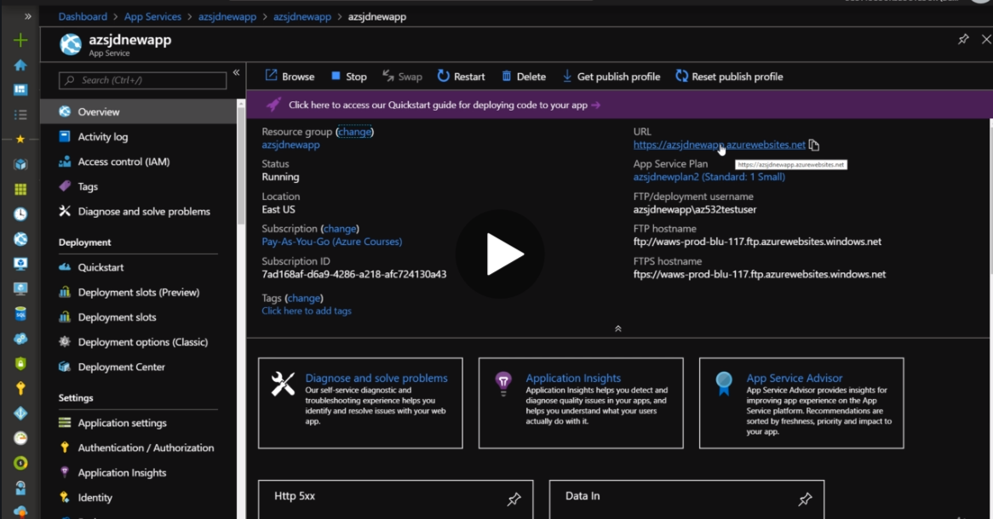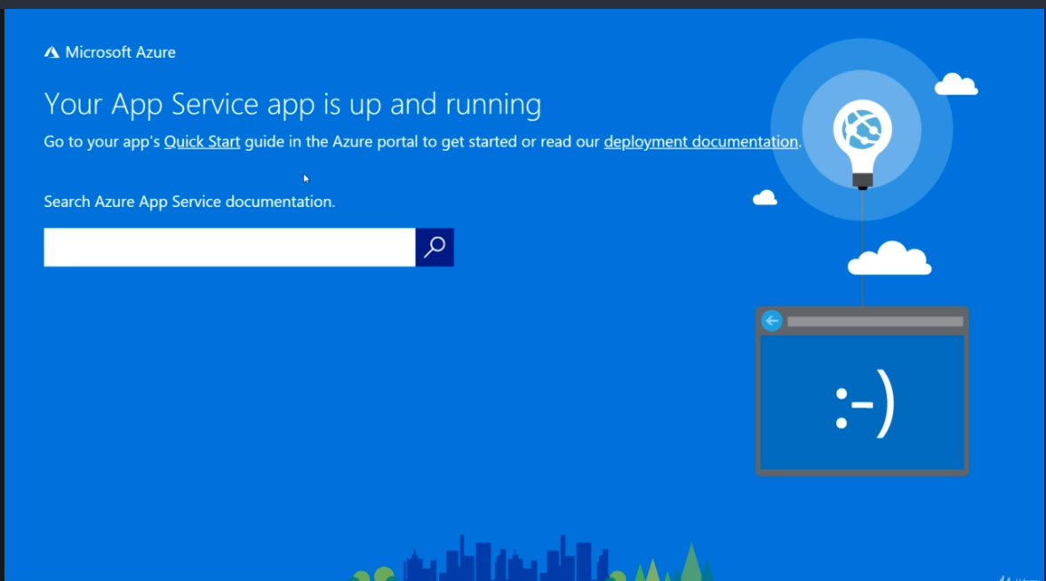
* We can also create custom domains for our Webapp application here on the page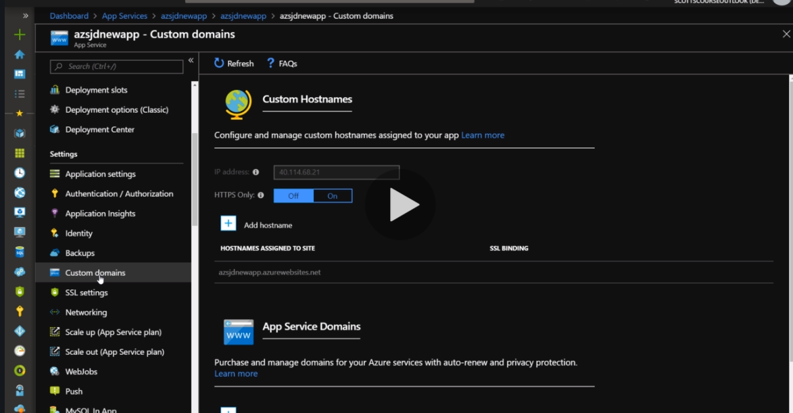
* Can also buy app service domains
* Backups option is also there for some of the planss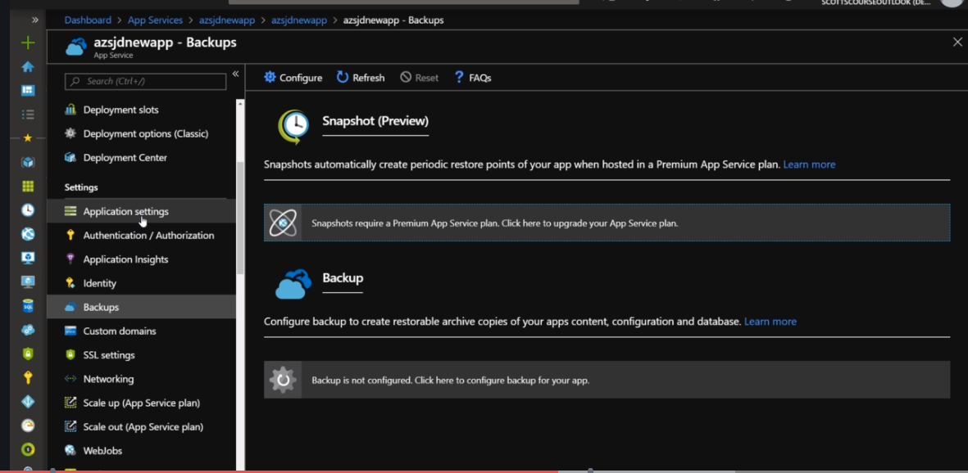
* Application setting in Configuration tab is the most important to configure it. 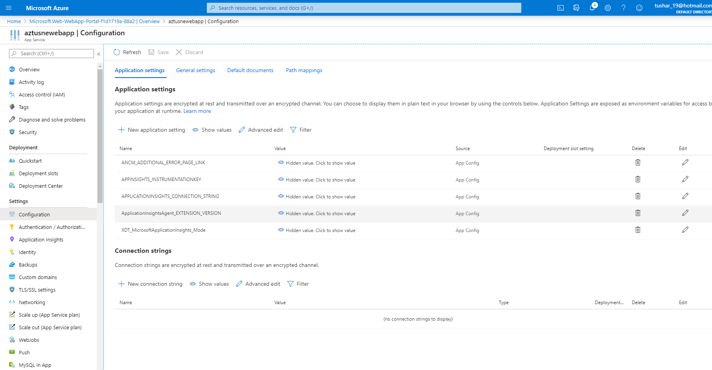
* Turn of evert port and language which you are not using to configure the application to avoid any security risks